**Course One**

# Foundations of Data Science



# Instructions

Use this PACE strategy document to record decisions and reflections as you work through this end-of-course project. You can use this document as a guide to consider your responses and reflections at different stages of the data analytical process. Additionally, the PACE strategy documents can be used as a resource when working on future projects.

# Course Project Recap

Regardless of which track you have chosen to complete, your goals for this project are:

* Complete the PACE Strategy Document to plan your project while considering your audience members, teammates, key milestones, and overall project goal.
* Create a project proposal for the data team.

# Relevant Interview Questions

Completing this end-of-course project will empower you to respond to the following interview topics:

* As a new member of a data analytics team, what steps could you take to get 'up to speed' with a current project? What steps would you take? Who would you like to meet with?
* How would you plan an analytics project?
* What steps would you take to translate a business question to an analytical solution?
* Why is actively managing data an important part of a data analytics team's responsibilities?
* What are some considerations you might need to be mindful of when reporting results?

**Reference Guide**

This project has three tasks; the following visual identifies how the stages of PACE are incorporated across those tasks.

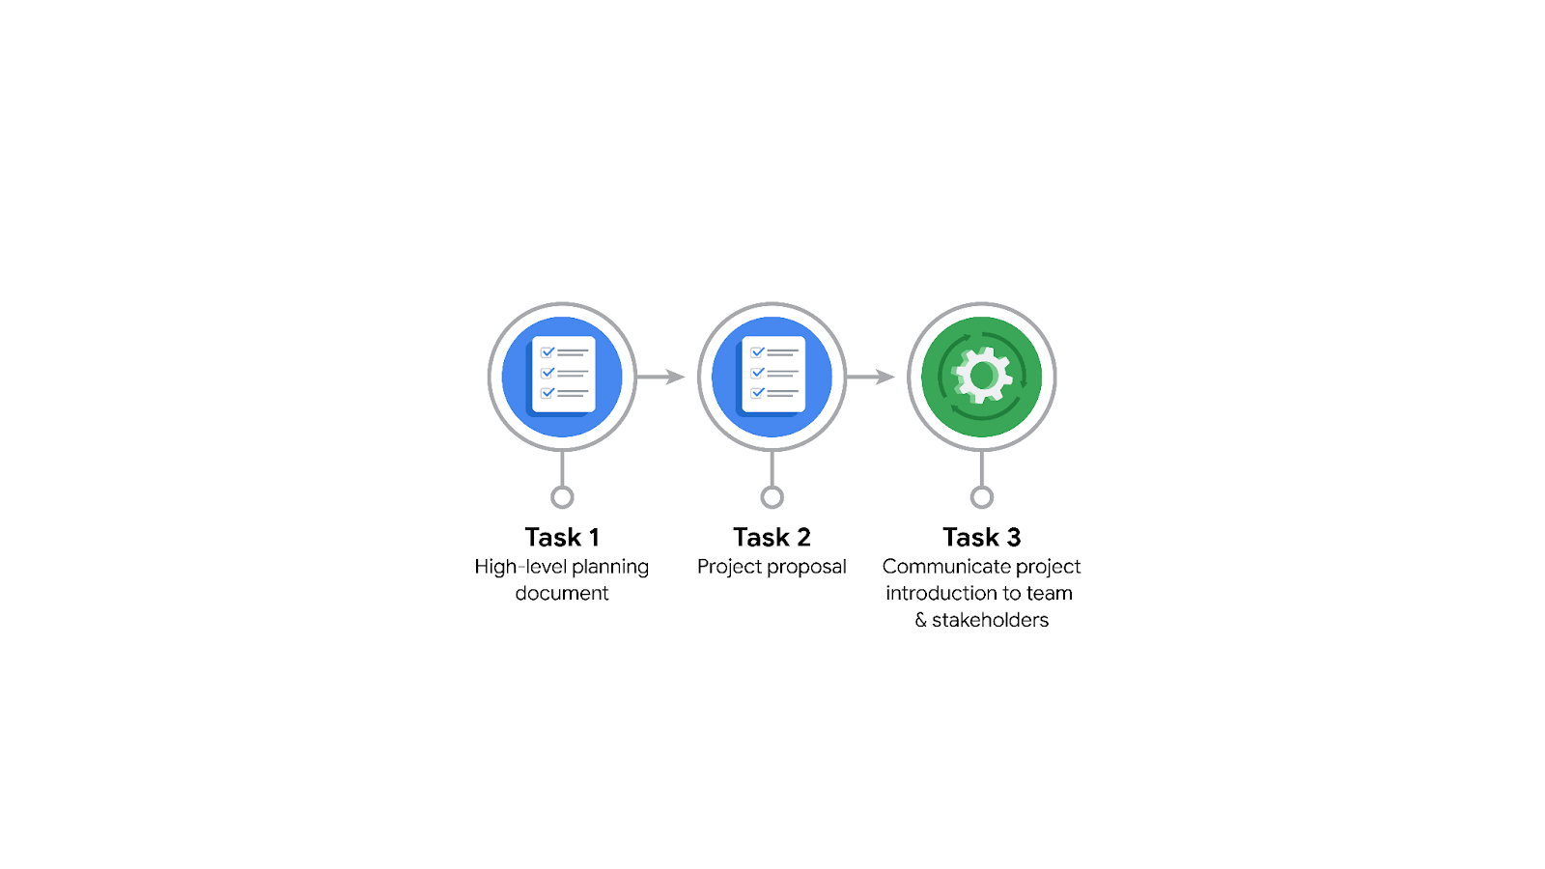

**Data Project Questions & Considerations**

**PACE: Plan Stage**

* Who is your audience for this project?
* **Primary Audience**: Waze’s leadership team, including Harriet Hadzic (Director of Data Analysis) and Emrick Larson (Finance and Administration Department Head), who require insights for strategic decisions.
* **Secondary Audience**: Data team members (technical communication) and operations teams like Ursula Sayo (Operations Manager) for actionable insights.
* What are you trying to solve or accomplish? And, what do you anticipate the impact of this work will be on the larger needs of the client?
* **Objective**: Develop a machine learning model to predict monthly user churn.
* **Impact**:

1. Identify high-risk users prone to churn.
2. Understand factors driving churn.
3. Propose proactive engagement strategies for retention.
4. Drive overall business growth for Waze.

* What questions need to be asked or answered?
* Who are the users most likely to churn?
* What are the primary reasons for user churn?
* Which features or usage patterns correlate with retention or churn?
* How accurate and actionable is the predictive model?
* What resources are required to complete this project?
* **Technical Resources**: Tableau, Python, machine learning libraries (e.g., scikit-learn, pandas, matplotlib).
* **Human Resources**: Contributions from data analysts (EDA, feature engineering), data scientists (model development), and project managers.
* **Data**: Access to anonymized Waze user data with variables relevant to churn behavior.
* **Budget and Time**: Allocations for development, validation, and stakeholder presentations.
* What are the deliverables that will need to be created over the course of this project?
* A cleaned, analyzed dataset ready for modeling.
* Exploratory Data Analysis (EDA) report with key findings.
* A predictive machine learning model with performance metrics (e.g., precision, recall, accuracy).
* Visualizations and dashboards summarizing insights.
* Final presentation for leadership, including actionable recommendations.

## **THE PACE WORKFLOW**

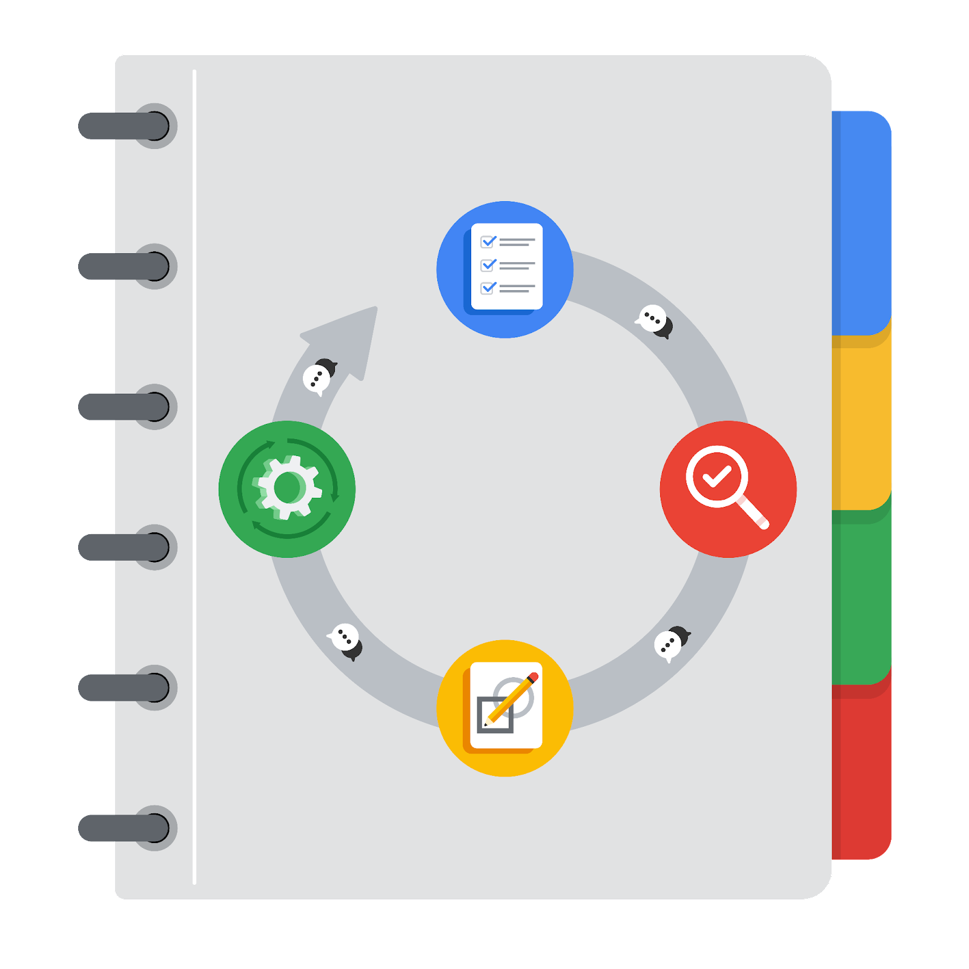

**[Alt-text: The PACE Workflow with the four stages in a circle: plan, analyze, construct, and execute.]**

You have been asked to demonstrate for the company's data team how you would use the PACE workflow to organize and classify tasks for the upcoming project. Select a PACE stage from the dropdown buttons. A few tasks involve more than one stage of the PACE workflow. Additionally, not every workplace scenario will require every task. Refer back to the Course 1 end-of-course portfolio project overview reading if you need more information about the tasks within the project.

### 

### **Project tasks**

Following are a group of tasks your company’s data team has determined need to be completed within this project. The data analysis manager has asked you to organize these tasks in preparation for the project proposal document. First, identify which stage of the PACE workflow each task would best fit under using the drop down menu. Next, give an explanation of why you selected the stage for each task. Review the following readings to help guide your selections and explanation: [The PACE stages](https://www.coursera.org/learn/foundations-of-data-science/supplement/4OtHr/the-pace-stages) and [Communicate objectives with a project proposal](https://www.coursera.org/learn/foundations-of-data-science/supplement/79Ysh/communicate-objectives-with-a-project-proposal). You will later reorder these tasks within a project proposal.

1. **Evaluating the model:** Execute

Why did you select this stage for this task?

Validates the model's accuracy, consistency, and reliability.

1. **Conduct hypothesis testing:** Analyze **and** Construct

Why did you select these stages for this task?

Tests assumptions and identifies relationships between variables.

1. **Begin exploring the data:** Analyze

Why did you select this stage for this task?

This is the first step to understand data trends and patterns.

1. **Data exploration and cleaning:** Analyze

Why did you select these stages for this task?

Ensures data quality and prepares it for analysis.

1. **Establish structure for project workflow (PACE):** Plan

Why did you select this stage for this task?

Ensures clear organization and alignment with project goals and timelines.

1. **Communicate final insights with stakeholders:** Execute

Why did you select this stage for this task?

Shares actionable insights and recommendations.

1. **Compute descriptive statistics:** Analyze

Why did you select this stage for this task?

Summarizes key attributes and trends in the dataset.

1. **Visualization building: Construct**

Why did you select these stages for this task?

Creates graphs and charts for both analysis and presentation.

1. **Write a project proposal:** Plan

Why did you select this stage for this task?

This task establishes the foundation of the project, defining objectives, milestones, and deliverables.

1. **Build a regression model:** Construct

Why did you select this stage for this task?

Provides a baseline predictive model for churn.

1. **Compile summary information about the data:** Analyze

Why did you select this stage for this task?

Gather all data, and resources necessaries to develop the model

1. **Build machine learning model:** Construct

Why did you select this stage for this task?

Develops a robust predictive model using advanced techniques.